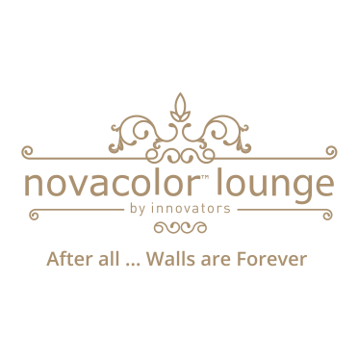**Innovator bring Life to Interior and Exterior Walls in Pakistan**

After all… Walls are forever

Backed by novacolor Italy, and core creative expertise of Mr. Hafeezullah Sheikh and versatile industry experience of Mr. Nasar Shaikh, with proved track record with an experience of about 25 years,  Innovators is bringing life to interior and exterior walls of various styled homes and commercial buildings. Serving their clientele since years, Innovators is a reliable name towards architects, builders and homemakers looking forward to give top-notch style to their wall finishes.A

“Innovators” established in 2003. Innovators provides unique solutions to its customers for a) Wall Coating and b) Interior and exterior Wall Finishing. It has Over 120 acrylic based/lime based highly UV resistant, waterproof and durable wall finishes available in various color from Lounge to Room, Porch to Building, and Pool to Bathroom. It was engaged in Residential and Commercial Projects which include and not limited to Financial Institutions, MNCs, Hospitals, Hotels, schools, Theaters and man others.

All our Projects used the state of the art solutions which resulted in an immense look and feel with a Unique Selling Proposition (USP) of 10 to 15 Years Warranty.

Innovators has gained popularity due to its creativity, consistency of results and innovative solutions as per the client requirements, good quality products and services and has therefore, become the first choice among the top architects and designers. Innovators has its own Display centre in Karachi and Lahore It is also working all over the Country and is planning to open 01 outlet in Islamabad.

Innovators is an Exclusive Partners of NOVACOLOR S.R.L – An Italian company in Pakistan

Novacolor was first established in 1982, in the heart of one of the most productive areas of Italy. Through the years, thanks to the intuition and creativity of the management, and to the careful selection of high quality raw materials, Novacolor expanded, thus offering architects and designers worldwide a complete assortment of textured effects and polished plasters, for interiors and exteriors, as well as wall coatings for modern or historical town settings.

**THE BEST PARTNER OF ARCHITECTS AND DESIGNERS**

The combination of ideas, intuition, exhaustive studies on the feasibility and development of new products, make Novacolor a reference brand worldwide and a recognized partner for renowned architectural and design studios. Today Novacolor is represented in over 50 countries and is proud of its cooperation with prestigious international partners.

**Research & Development Made in Italy**

Targeted investments in development, research and technology, in depth and in situ analysis, ground-breaking attitude towards design, together with a strong and committed internal organization, make of

Novacolor one of the biggest players in the world of architectural design and a trendsetter in the textured paints segment.

***Novacolor decorative solutions:***

* Use of organic and high-quality raw materials;
* Products with low environmental impact;
* Enhancement of the surface as a “piece of art”;
* Creativity, R&D, cutting edge products;
* Colours and textures that set trends.

R&D, the real "engine" of the company, a team of extremely qualified technicians specialized in the creation of new decorative effects, research of better performing raw materials, brand new applications techniques and creative textures.

A certified quality standard is ensured at all manufacturing levels. The company also enjoys a highly-organized sales and marketing team. The attitude of the management and a quality-oriented approach, along with the pro-active involvement of the whole team, make Novacolor a UNI EN ISO 9001:2008 certified company.

**Novacolor Green Approach: Design Wellbeing**

Novacolor is extremely sensitive towards environmental issues. As a result, the company has made significant progress in recent years by reducing the carbon footprint of the products but especially of the manufacturing facilities.

Both the product formulation and the manufacturing process are driven by a conscious green approach. Novacolor manufactures and distributes innovative materials worldwide, with a very low release of VOCs (Volatile Organic Compounds).

In addition, the company is strategically committed to the analysis of the LCA (Life Cycle Assessment) of all products. LCA studies the whole life cycle of a product and its environmental impact.

Novacolor decorative textures make the environment unique and elegant while contemporarily improving our life standards.

**Customer-Centric Approach**

Ideas as absolute value. Ideas create a direct connection with the client. This is why Novacolor is a customer oriented company and “Customer Service” is of primary relevance for us. Novacolor is an extremely dynamic company, with a very dedicated team, demonstrating great passion for its work and expertise at all levels.

High competence and know-how contribute to improving the working standards of people and companies. Novacolor not only sells and distributes products worldwide: the company is committed to offering full training to clients to ensure the proper use of its decorative wall coatings and special architectural paints.